**[Fig. FILE](https://docs.google.com/presentation/d/1vHNr9X7xUqI615mWn_HFrkFjPoCi6pxsN1HFoAYvIqA/edit?usp=sharing)**

1. **In Situ Evidence of Continental-Scale Warming, Oxygen Decline, and Eutrophication in U.S. Estuaries**
2. **Warming, Deoxygenation, and Eutrophication Observed Across U.S. Estuaries Using In Situ Measurements**
3. **In Situ Observations Reveal Continental-Scale Warming, Oxygen Decline, and Eutrophication in U.S. Estuaries**

Kaitlin L. Reinl1\*, Robert P. Dunn2, Kimberly A. Cressman3, Theophilos Collins4, Jennifer L. DeBose5,6, Carl T. Friedrichs7, Alicia R. Helms8, Christopher Kinkade9, Julie L. Krask2, Dave Parrish7, Hannah N. Nicklay1, Justin T. Ridge10, Denise M. Sanger11, Jacob A. Cianci-Gaskill12, Nicole Dix13, Thomas M. Grothues14, Steven E. McMurray12, Christopher Peter15

\*Indicates corresponding author

1. Lake Superior National Estuarine Research Reserve, University of Wisconsin -Madison Division of Extension
2. North Inlet-Winyah Bay National Estuarine Research Reserve, Baruch Marine Field Laboratory University of South Carolina & Ecological Dynamics LLC, Greensboro, NC
3. Catbird Stats, LLC, Gautier, MS
4. Waquoit Bay National Estuarine Research Reserve, Falmouth, MA
5. Grand Bay National Estuarine Research Reserve, Moss Point, MS;
6. Coastal Marine Extension Program, Mississippi State University, Biloxi, MS
7. Chesapeake Bay National Estuarine Research Reserve in Virginia, Virginia Institute of Marine Science, Gloucester, VA
8. South Slough National Estuarine Research Reserve, Oregon Department of State Lands
9. NOAA NOS Office for Coastal Management, Silver Spring, MD
10. North Carolina Coastal Reserve and National Estuarine Research Reserve, North Carolina Department of Environmental Quality Division of Coastal Management, Beaufort, NC
11. ACE Basin National Estuarine Research Reserve, South Carolina Department of Natural Resources, Charleston, SC
12. Old Woman Creek National Estuarine Research Reserve, Ohio Department of Natural Resources, Huron, OH
13. a) Guana Tolomato Matanzas National Estuarine Research Reserve, Florida Department of Environmental Protection, St. Augustine, FL; b) University of North Florida, Jacksonville, FL
14. Jacques Cousteau National Estuarine Research Reserve, Rutgers University, Tuckerton, NJ
15. Great Bay National Estuarine Research Reserve, New Hampshire Fish and Game

### Summary

### Estuaries are sentinel ecosystems for understanding the impacts of climate change, storm events, and land-use change, but availability of in situ data for continental-scale comparative studies are relatively rare. Here, we document the status of water quality of U.S. estuaries across multiple climate zones using standardized, in-situ monitoring data to detail decadal-scale trends in key environmental parameters and investigate factors contributing to trends in eutrophication and hypoxia. Our analysis brings together more than 250 million data points from 94 million timestamps over the past two decades, providing unprecedented, direct evidence of widespread eutrophication and warming in estuaries, with significant increases in chlorophyll-a and water temperature at approximately two-thirds of sites. Additionally, half of sites are experiencing significant declines in dissolved oxygen, though there is little change in the extent of hypoxic conditions (DO < 2mg/L). Ultimately, changing nutrient levels, not temperature, appear to be the primary driver of increases in chl-a, while increasing temperature and chlorophyll-a are the main factors behind declining oxygen concentrations. These analyses reinforce that changes in coastal ecosystem dynamics are complex and driven by multiple interacting factors, requiring large-scale, standardized data collection to untangle .

### Introduction

Estuaries, situated at the critical interface between terrestrial and aquatic ecosystems, are ecologically and economically valuable environments increasingly threatened by anthropogenic and climate-driven stressors. While estuaries vary considerably across geographic settings, they are consistent in serving as critical nursery habitats, fostering high levels of productivity, and facilitating active biogeochemical cycling largely driven by mixing of chemically-distinct water masses as well as nutrient inputs from surrounding watersheds1–3. This productivity and habitat provision equates to billions of dollars in ecosystem services to coastal economies, particularly for fishery, recreation, and tourism industries4. However, the locations of estuaries at the land-water interface expose them to both terrestrial (e.g., land use change, runoff) and aquatic (e.g., sea level rise, ocean acidification, harmful algal blooms) stressors5–8.

Eutrophication is one of the primary threats to the water quality and condition of estuarine ecosystems9,10. During eutrophication, increased nutrient inputs trigger overgrowth of phytoplankton, in some cases resulting in harmful algal blooms (HABs), which have been increasing in extent and frequency over previous decades11. Decomposition of phytoplankton aggregations following these blooms can severely lower oxygen levels through microbial uptake, causing hypoxia (defined here as dissolved oxygen [DO] < 2 mg/L) and anoxia (complete oxygen depletion). These low-oxygen events reduce estuarine nursery function and negatively impact fish populations12 and benthic macroinvertebrate communities13. Further, hypoxia can alter sediment redox conditions, leading to internal nutrient loading of dissolved nutrients back into the water column, creating a self-sustaining mechanism for subsequent blooms6,11. Increased phytoplankton biomass also reduces light penetration in the water column and to the benthos, triggering negative ecosystem-level impacts14,15. Coastal eutrophication has been estimated to cost $100 million annually for the US, and $1 billion for EU nations, due to public health concerns, lost recreational opportunities, and degraded commercial fisheries16. Coastal eutrophication and hypoxia are longstanding issues in the U.S., and despite regulatory efforts dedicated to combating these issues, they continue to be a major ecological, economic, and public health issue.

Estuaries are considered sentinel ecosystems for understanding the impacts of climate change17,18, storm events19,20, and land-use change21,22, but in situ, continental-scale comparative studies are relatively rare. Observations of environmental conditions and associated ecological processes from individual estuaries23–26 or regional assessments18,27, while highly informative, have limited broad-scale application due to the diversity in estuary attributes across continental scales. Large-scale assessments (e.g., national, continental, and global) of estuarine eutrophication have focused on qualitative syntheses or remotely sensed data11,28,29. While these data types are critical to estimate spatial patterns at broad scales, they suffer from observation bias and interpretation, coarse or limited resolution and quality (e.g., gaps in time-series coverage), mismatch in time and space leading to missed events, pixel bleed and bottom reflectance in small or shallow estuaries30, and lack of finer-scale ground-truthing. Conversely, in-situ data collected at high spatial and temporal resolutions provides objective, replicable, and high-integrity measurements that enable the characterization of disruptive events and sustained trends in these systems.

The U.S. National Estuarine Research Reserve System (NERRS) System-Wide Monitoring Program (SWMP) was designed to quantify short-term variability and long-term ecosystem change within a network of 30 coastal locations (ie., reserves) around the United States, including Hawaii, Alaska, and Puerto Rico5,31–33. SWMP data have previously been utilized to characterize spatial and temporal patterns in water quality34–36, investigate the importance of autotrophic and heterotrophic processes37,38, understand mechanisms regulating phytoplankton biomass39, and quantify the effects of eutrophication12 and ocean acidification40, among others. Given the range of geomorphologies and climatic conditions of the estuaries within the NERRS, the application of standardized methods across all monitored sites, and time span of sample collection (i.e., up to 30 years), SWMP is uniquely positioned to address large temporal and spatial-scale questions about the status of estuaries in the United States, trends in eutrophication and hypoxia, and the factors contributing to those trends41. Here, we document the status of estuarine ecosystems across the NERRS using standardized, in situ monitoring data, detail decadal-scale trends in key environmental parameters, and investigate factors contributing to trends in eutrophication and hypoxia. Our analysis brings together > 250 million data points collected from approximately 100 stations for up to three decades, providing an unprecedented investigation of in situ estuarine conditions at a continental scale.

### Results & Discussion

#### *Status of water quality in U.S. estuaries*

Across 129 monitoring sites located in 29 of 30 National Estuarine Research Reserves (**Supplementary Table 1)**, cluster analysis revealed four types of estuarine sites. exhibiting shared biochemical characteristics (**Figs. 1**, **2, Supplementary Table 2, 3**). Water temperature ranged from 6.2 to 29.3 oC across all clusters, and specific conductivity (SpCond) ranged from 0.2 to 69.9 mS/cm and included predominant fresh and saltwater influences, with turbidity running from 2.7 to 55 NTU. Dissolved oxygen modes (mean of median by cluster) fell between 2.4 and 10.8 mg/L with an average median value by cluster of 7.4 mg/L. The pH among all 129 sites was somewhat variable, with a mode of 6.3 to 8.3. Chlorophyll-a modes by cluster ranged from 1.07 to 30.5 𝛍g/L, while NO23, NH4, and PO4 had considerably large ranges, falling between 1.3-3,098, 2-445.3, and 0.8-230.6 mg/L respectively. Sites in cluster A exhibit the highest average dissolved inorganic nitrogen (DIN; NO23=585.8 mg/L, NH4=75.1 mg/L), lowest pH (7.34), and lowest specific conductivity (7.9 mS/cm; SpCond is highly correlated with salinity in this dataset, **Supplementary Fig. 1**), often associated with the most freshwater sites. These sites also have the highest mean turbidity (21.7 NTU) and chlorophyll-a (chl-a; 9.0 𝛍g/L), suggesting higher suspended particle concentrations (including organic detritus). Cluster B sites experience higher SpCond (39.8 mS/cm), pH (7.9), and temperature (24.9 oC), and lower DIN than the other clusters (NO23=15.7 mg/L, NH4=21.9 mg/L), suggesting more influence from warm marine waters compared to other sites. Cluster C sites have the lowest average water temperatures (12.5 oC) accompanied by highest dissolved oxygen (DO; 8.9 mg/L ), and a large range of SpCond (0.26-69.9 mS/cm). Importantly, this cluster includes many sites where warming trends are strongest, including in the northeast U.S. (**Fig. 3**). These sites also tend to have the lowest mean chl-a (2.34 𝛍g/L) concentrations as well as low turbidity (2.7 NTU), suggesting relatively low organic and inorganic particle concentrations. Cluster D somewhat mirrors Cluster B with relatively higher water temperatures (20.7 oC) and low mean DO concentration (6.2 mg/L), but these sites are distinguished by their high mean ammonium (NH4; 59.5 mg/L) and orthophosphate (PO4; 53.4 mg/L) concentrations. Though the four identified clusters are distinct at their centroids, sites near the edges become more similar to each other (**Fig. 2 and Supplementary Fig. 2**). These sites may exhibit characteristics of other clusters, and in reality, fall somewhere on a continuum of characteristics associated with a given cluster42.

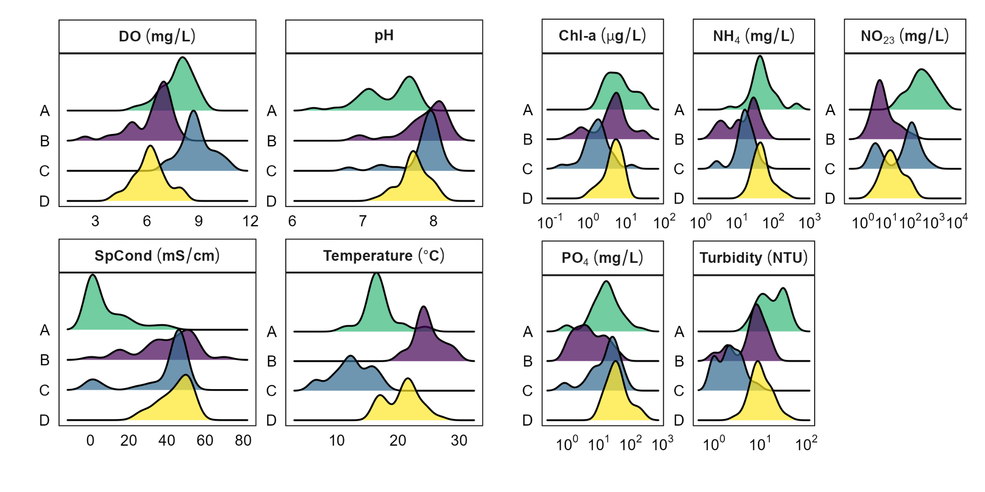

**Fig. 1**. Distribution of median water quality and mean nutrient characteristics in each cluster.



**Fig. 2**. Geographic distribution of clusters associated with each cluster. The PCA shows PC1 (32.4%) on the x axis and PC2 (25.9%) on the y axis with clusters. A more detailed version that includes PC 3 can be found in **Supplemental Fig. 2**.

In addition to being biochemically distinct, the clusters exhibit continental-scale patterns based on latitude and temperature (**Fig. 2**). Cluster A and C generally appear north of 37 deg N, and Cluster B and D are more often found south of this latitude. Seventeen reserves had sites that fell within only one cluster, while nine reserves had two of the four clusters represented. Finally, three reserves (Great Bay, NH, Jacques Cousteau, NJ, and Chesapeake Bay, VA) have sites represented in Clusters A, C, and D. These patterns seem to be associated with latitude, which would influence temperatures, in turn impacting DO levels. Other factors that likely contribute to patterns in cluster grouping are primary productivity, indicated by chl-a concentrations, and turbidity, which is likely at least somewhat linked to chl-a concentrations. These clusters represent distinct water quality regimes that reflect the status of these 129 sites, offering a useful framework for interpreting spatial patterns in estuarine nutrient dynamics, salinity gradients, and trophic state across the national network.

#### *Long-term trends in estuarine conditions*

A strong majority of 99 sites across 27 U.S. estuaries are experiencing significant, increasing trends in chl-a (70%) and water temperature (66%), and half of sites (49%) are exhibiting significant reductions in DO concentrations ~~e~~(**Fig. 3, Supplementary Table 4**). These findings are consistent with evidence of widespread warming, eutrophication, and hypoxia from other studies of coastal environments11,43. Despite the proportion of sites exhibiting oxygen declines, only eight sites exhibited significant increasing trends in the proportion of time under hypoxic conditions (DO < 2 mg L-1 ; APA-EB, SAP-DC, TJR-BR, TJR-OS, ELK-PW, HUD-TN, OWC-DR, and SFB-GC; reserve station codes are in **Supplementary Table 1**), suggesting that while trends in DO are generally negative, water quality conditions have not yet deteriorated to the degree at which large ecological impacts would be expected.

Nutrient trends (NO23, NH4, and PO4) showed variability in their directionality, both increasing and decreasing across U.S. estuaries, though the direction of PO4 and NH4 trends were generally similar (**Supplementary Fig. 3**). However, the relationships between NO23 and PO4, and NO23 and NH4 were more variable (**Supplementary Figs. 4,5**), highlighting the complex nature and interactions between these compounds. These nutrients are highly sensitive to many unique biogeochemical changes at the local scale6, making establishing clear relationships between them at the continental scale exceptionally difficult. In contrast, the overall increase in temperature exhibited by most estuaries almost assuredly played a key role in reducing dissolved oxygen levels (as documented in the section below).

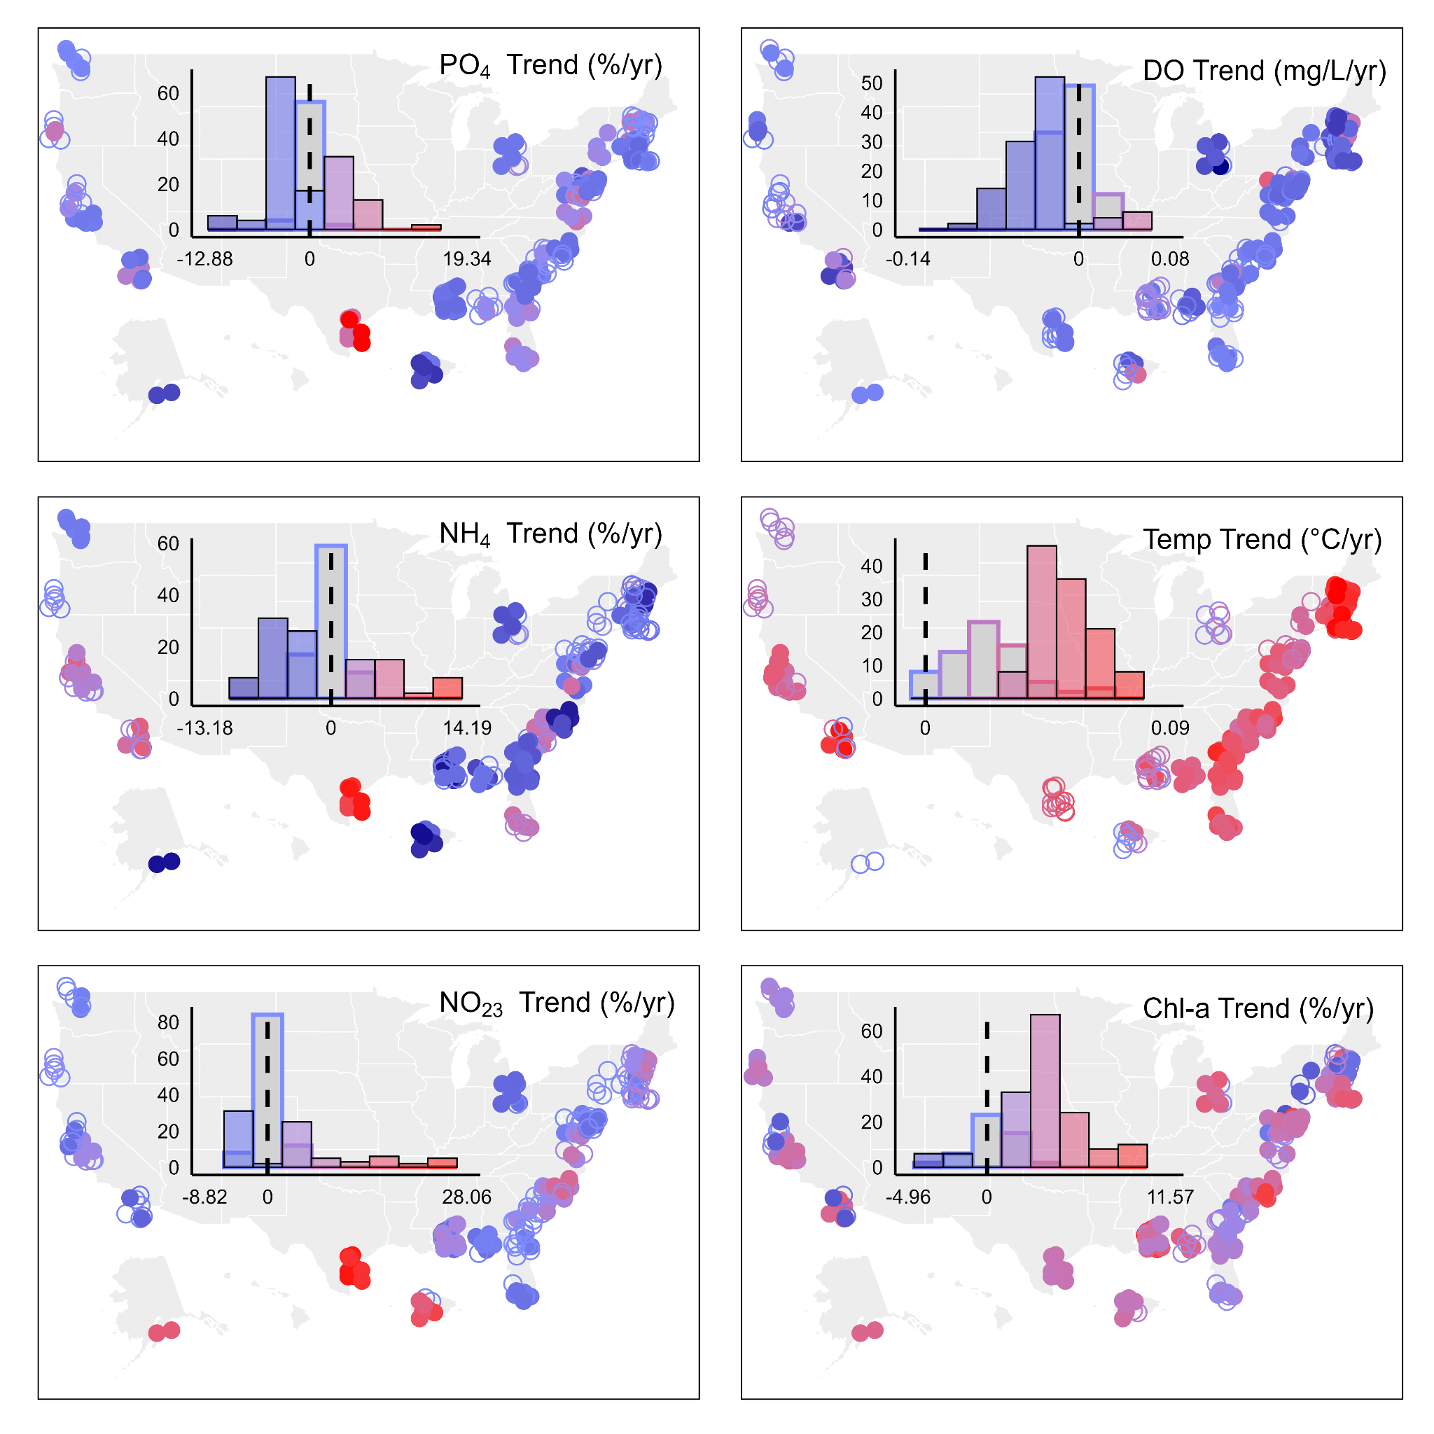

**Fig. 3.** Geographic patterns of slopes for long-term trends in six water quality parameters: orthophosphate (PO4), ammonium (NH4), nitrite+nitrate (NO23), dissolved oxygen DO, temperature, and chlorophyll-a (chl-a) concentration. Units are % year -1, with the exception of DO (mg L-1 year-1) and Temp (°C/yr). Within each panel, the histogram shows the distribution of slope values across all sites; shaded location circles and histogram bars denote statistically significant slopes (p < 0.05). Shading within the circles follows the same scale as the histograms.

The increasing temperature and chl-a trends coupled to decreasing dissolved oxygen concentrations were not unique to a particular cluster (**Fig. 4**), although there are some notable regional patterns (**Fig. 3**). Many of the highest rates of warming and steepest declines in oxygen levels were observed at sites in the Northeast U.S. (WEL, GRB, WQB, and NAR; all reserve and station codes in **Supplementary Table 1**) with rates of temperature increase ranging from 0.06-0.08 °C per year, similar to other recent estimates of warming in this region44. Other locations with similar rates of change in temperature include sites at Tijuana (TJR) and Sapelo Island (SAP) NERR, both located at similar, more southerly latitudes (~ 32 °N). Lower rates of temperature increase (and therefore less oxygen decrease) tend to be common further north along on the west coast, which may be due to the modulating effects of ocean upwelling damping local atmospheric and estuarine warming45.

**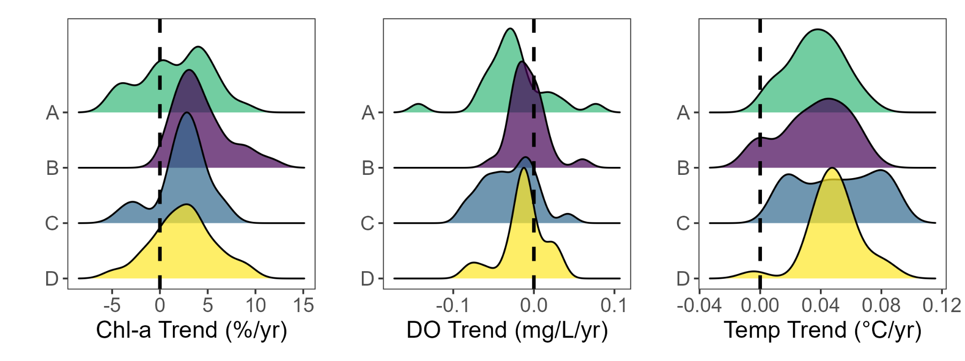**

**Fig. 4.** Trend slopes for chl-a, dissolved oxygen, and water temperature by cluster.

#### *Potential drivers of estuarine eutrophication and oxygen declines*

Temporal changes in chl-a concentration across U.S. estuaries were best predicted by corresponding site-level trends in NH4, PO4, and turbidity, with a relative importance of 0.98, 0.95, and 0.90, respectively (**Fig. 5**, **Supplementary Table 5,** and **Supplementary Fig. 6**). Median chl-a (i.e., trophic status) also predicted chl-a trends well, with a relative importance of 0.70. Of the 165 chl-a models with ΔAICc < 4 (AIC: Akaike Information Criterion, AICc: corrected AIC), these variables (in the order presented above) appeared in 163, 157, 145, and 109 of the candidate models. The marginal R2 (this value describes fixed effects only46) for the global model (i.e., including all predictors) was 0.19, while the conditional R2 (i.e., complete model with fixed and random effects) was 0.71, meaning that including a random effect for each of the 27 reserves (i.e., allowing intercept to vary for sites in each reserve to allow for baseline differences) explained a significant amount of the variance in chl-a trends across the 99 long-term monitoring sites. When only including the top four predictors, the marginal R2 was 0.10 and the conditional R2 was 0.60.

Long-term changes in DO concentration was best predicted by trends in temperature (inversely related; i.e., increasing temperature predicts larger decreases in dissolved oxygen), SpCond (positively related), and chl-a (inversely related; i.e., high chl-a trends predict larger decreases in dissolved oxygen as nearly all DO slopes are negative; **Supplementary Fig. 7**), as well as median chl-a, represented as the log (positively related; i.e., higher median chl-a predicts smaller decreases to possible increases in dissolved oxygen), with relative importance of 1.00 for all four predictors (**Fig. 5** and **Supplementary Table 6**). Thus, all four predictors have essentially equal importance. Temperature, SpCond, and chl-a trends appeared in all 139 models with ΔAICc<4, while log of median chl-a (trophic status) appeared in 137. The global model yielded an adjusted R2 of 0.12 while these four predictors yielded an adjusted R2 of 0.14.

Surprisingly, we found no clear relationships between Land Use/Land Cover (LULC) and trends in estuarine chl-a, DO, and nutrient concentrations (**Supplementary Figs. 8-12**). Nonetheless, we believe it is likely that LULC is at least somewhat related to these changes because aspects of LULC, such as urbanization, have been linked to riverine and estuarine warming18,47. Furthermore, watershed LULC characteristics directly influence upstream nutrient loads and inputs to estuaries, such as via increased run-off of fertilizers from agricultural landscapes, or wastewater intrusion into coastal groundwater and run-off from impervious surfaces within urbanized settings28,48. The resolution at which LULC was analysed (HUC 8 and HUC12) grouped multiple stations within the same watershed, limiting our ability to relate changes in land use with trends in water quality variables at specific stations. In addition, some reserve sites are located in less developed areas, which may explain the lack of association between long-term trends in water quality and LULC within our database. The degree to which our results are representative of other, potentially more anthropogenically-disturbed, estuaries requires additional investigation.

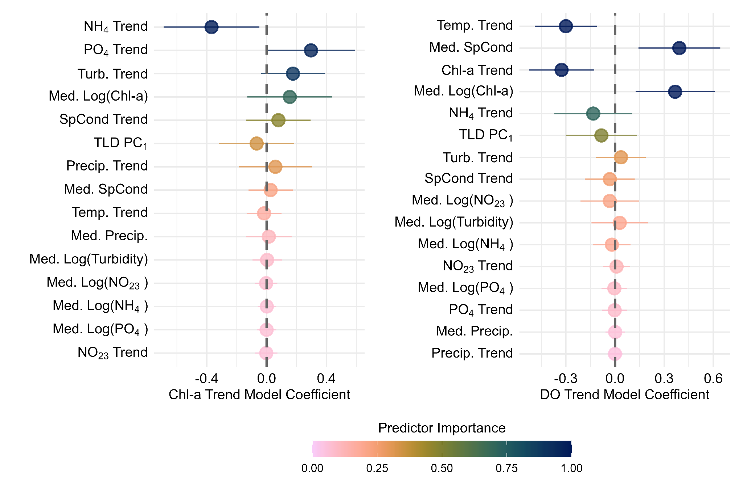

**Fig. 5**. Standardized coefficients based on model averaging. Colors represent relative importance of predictor variables; note that predictors are not presented in the same order between left and right panels. For chl-a, 165 of the original 32,768 potential model subsets were retained based on our delta AICc threshold of 4. For DO, 139 of the original 65,536 subsets were retained and used for coefficient estimation via model averaging. TLD PC1 indicates the first principle component of the PCA analysis for median temperature, DO, and latitude as model predictor (see methods).

Our results suggest that nutrients are more strongly associated with trends in phytoplankton biomass than water temperature, specifically NH4 and PO4, while NO23 was at the bottom of the predictor pool. Typically, inorganic nitrogen has been identified as the most common limiting nutrient in coastal systems6, but this is not a spatiotemporal absolute. Phosphorus often limits phytoplankton growth during springtime in the Chesapeake Bay49 and drives chl-a variability at one location in Weeks Bay, Alabama USA50. Furthermore, PO4 typically limits growth in freshwater environments51, which is characteristic of upstream conditions in estuaries. This dynamic nature of estuaries along the freshwater-to-marine continuum is likely reflected in the modeling results showing that both N and P play a key role in predicting chl-a trends. Interestingly, it is decreasing trends in reduced forms of N (e.g., NH4), which are typically regarded as being more bioavailable (although not necessarily for diatoms52), and increasing trends in PO4 that were correlated with increasing chl-a concentrations. Planktonic primary producers can rapidly take up NH4, and so the declines in NH4 concentration may actually reflect increased uptake from increasing primary production, possibly driven by an increase in PO4 availability. These nutrient uptake rates may be further increased by coincident rises in temperature and subsequently, phytoplankton growth, reinforcing feedbacks between algal growth53.

Our dataset did not allow us to directly analyze N:P ratios in our dataset because of numerous instances in which both N and P were below the limit of detection, preventing generation of a meaningful ratio. However, the associations of decreasing NH4 and increasing PO4 trends with chl-a trends supports a claim that nutrient ratios and availability (i.e., stoichiometry) is broadly changing, with important implications for primary productivity, phytoplankton community composition, and food web dynamics54. For example, it is more energetically efficient for dinoflagellates and cyanobacteria to utilize reduced forms of N, while diatoms often prefer oxidized52. Dinoflagellates and cyanobacteria are generally less favorable to grazers than diatoms, suggesting that changes in nitrogen species availability could have implications for phytoplankton community structure that reverberate throughout the foodweb55,56. Shifts in N:P ratios can also influence the relative importance of mixotrophy, cell size, and toxin production in dinoflagellates and cyanobacteria, two key HAB-forming groups57.

An important consideration for interpreting our analyses of the putative drivers of chl-a trends is the lack of data describing the organic forms and total pools of N and P. Inorganic nutrients are generally understood to be the most bioavailable compounds for phytoplankton; however, organic N and P can be present at concentrations far exceeding inorganic forms, even by an order of magnitude58,59. Furthermore, many of the organic forms are indeed bioavailable to different phytoplankton taxa and/or can be recycled into more readily usable forms (i.e., NH4) at high concentrations upon organic matter decomposition and remineralization60–63. Unfortunately, organic nutrient forms are not consistently measured as part of SWMP on the national scale and could not be included in this analysis. Nonetheless, it is critical to note their potential role in explaining additional variance in trends in chl-a and nutrient cycles and highlight the need for future investigation of the relative importance of organic nutrients to estuarine water quality.

The importance of trends in turbidity for predicting chl-a trends may reflect the increase in phytoplankton biomass and associated organic detritus in suspension. Alternatively, the relative importance of median SpCond (importance value = 0.21; **Supplementary Table 5**) and precipitation trend (importance value = 0.31; **Supplementary Table 5**) alongside turbidity could indicate that turbidity trends may also indirectly represent altered nutrient and light dynamics resulting from terrestrial inputs and changes in rainfall frequency, duration or intensity, hydrological mixing patterns, or overall estuarine geomorphology64,65. However, precipitation, SpCond, and turbidity were not highly correlated in the dataset, indicating that the linkages between these variables are not key drivers of turbidity in this dataset.

The equal weight assigned to trends in chl-a and temperature for predicting changes in DO concentrations could be tied to several complex ecological processes. Temperature directly governs oxygen solubility and is therefore inversely related to dissolved oxygen concentrations; however, solubility alone does not account for changes in DO (**Supplementary Fig. 13**). The importance of chl-a trend (negatively related to DO trend) may be due to increased oxygen consumption via accelerated organic matter decomposition, and in some cases reduce oxygen sufficiently to alter redox conditions and reintroduce nutrients into the water column that can fuel phytoplankton growth66; however, our analyses do not indicate that instances of hypoxia are increasing over time. Still, there are some locations where the positive feedback between eutrophication and hypoxia is being demonstrated. For example, Old Woman Creek (OWC) NERR is not experiencing increasing temperature but is experiencing significant increases in chl-a and decreases in DO, as well as an increasing trend in hypoxia at the Darrow Road (OWC-DR, **Supplementary Table 1**) site. Additionally, storm events drive nutrient inputs in this system, and climate change is expected to increase the magnitude of precipitation events but have a moderate effect on warming air temperature throughout the region67. Storm-driven nutrient pulses were likely not well-represented in our analyses because they often occur between monthly nutrient sampling68, but were captured in the increasing chl-a and decreasing DO trends we observed in Old Woman Creek. Thus, in many instances, it is likely that the processes that cause declines in oxygen are occurring, even if concentrations do not always drop to hypoxic levels.

The positive relationship between median SpCond and DO trends may be reflective of the location of sites along the freshwater-to-marine gradient. Lower SpCond sites experience more freshwater influence, and these sites are also the most productive, as indicated by median chl-a concentration (**Fig. 1**), resulting in more oxygen depletion as described above. However, the observed oxygen declines are nearly equally distributed along the freshwater-to-marine continuum. There is also a positive relationship between median chl-a and DO trends and median chl-a and chl-a trends. That is, the highest rates of DO declines are occurring at sites with lowest median chl-a (i.e, the least productive sites; **Supplementary Figs. 14, 15**), and the highest rates of increase in the chl-a are the most productive sites (**Supplementary Fig. 6**). This is surprising given the inverse relationship between DO trends and chl-a trends; however, sites with low median chl-a also have the highest rates of temperature increase, suggesting that the linkage between median chl-a and DO trend is another signal of temperature effects on DO.

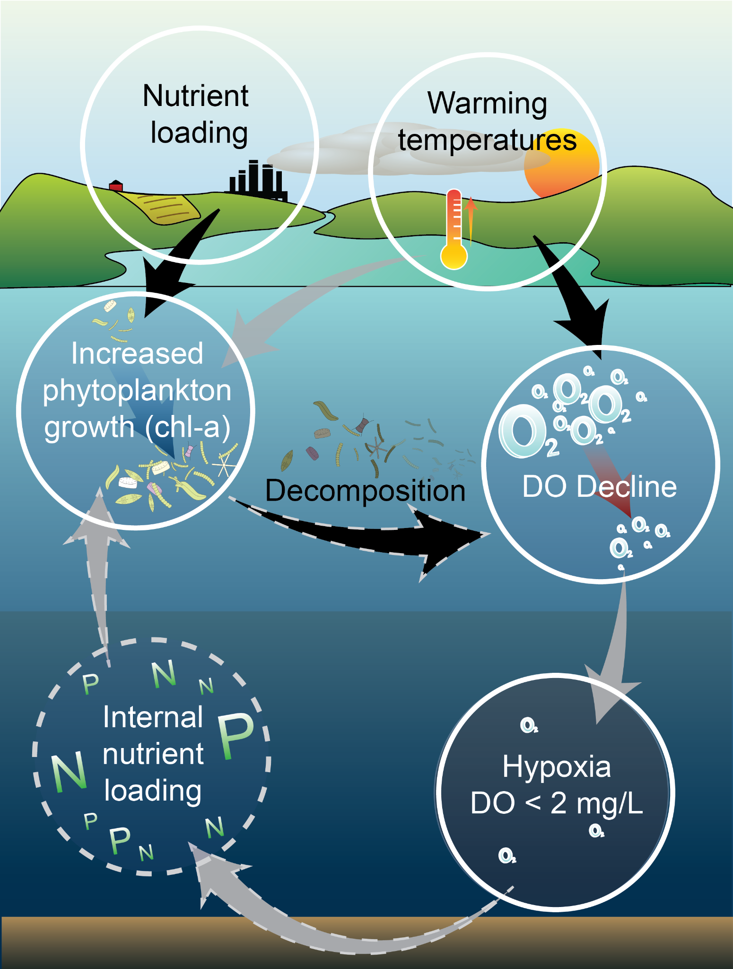

Fig. 6. Conceptual figure illustrating the positive feedback loop between eutrophication and hypoxia and the linkages that are represented in our modeling results. Gray arrows show processes that were not supported by our analysis and elements with dashed lines indicate processes that were not explicitly included in our analysis. Black arrows indicate relationships that were supported by modeling results.

The positive feedback between eutrophication and hypoxia is well documented6,43. Generally, increased nutrient inputs lead to a rise in primary productivity (e.g., chl-a). When phytoplankton biomass grows enough, the subsequent die-off and decomposition process can take up large quantities of oxygen, in some cases, bringing oxygen concentration low enough to alter redox conditions. This can result in release of dissolved nutrients back into the water column, creating a self-sustaining feedback loop (**Fig. 6**). The results of our analyses showed that some of these processes are happening, but the feedback loop is not closed. Our data did not show significant changes in the occurrence of hypoxic events, but we did observe widespread declines in dissolved oxygen. Further, distributions of median DO concentration (**Fig. 1**) indicate that concentrations are nearing the typical hypoxia threshold of < 2 mg/L and is often below 5 mg/L which can have important implications for the oxythermal habitat of fish and other organisms69.

Warming temperatures and altered nutrient loading spurred a series of changes to multiple dynamically interacting parameters in coastal waters (in-situ chlorophyll, nutrient, and dissolved oxygen concentrations) across the U.S that were captured by the NERRS SWMP dataset. Altered nutrient levels, not temperature, appear to be the primary driver of increases in chlorophyll-a in estuarine systems included in our dataset, while rising temperatures and productivity are responsible for declining oxygen concentrations. These analyses reinforce that coastal ecosystem dynamics are complex and driven by many interacting factors and highlight the importance of sustained long-term monitoring efforts to disentangle the relative influences of climate change and anthropogenic factors on coastal water quality and ecosystem health32. As coastal systems continue to respond to shifting baselines, only long-term, high-resolution observations will reveal the patterns that emerge over time. Such understanding is not only essential for anticipating ecological change but for guiding adaptive, science-based management in a rapidly transforming coastal world.

### Methods

*Data aggregation, QAQC process and parameter selection*

Water quality, meteorological, and nutrient data from January 2002 through December 2022 were obtained from the National Estuarine Research Reserve’s Centralized Data Management Office70 for all SWMP stations, located in 29 estuaries throughout the United States. Only data from currently active (as of 2022) SWMP stations were processed. Aggregation, compilation, and quality control were performed in R71 (v. 4.2.2), using the SWMPr72 (v. 2.5.0), and tidyverse packages73. All data flagged by local researchers as ‘rejected’ or ‘suspect’, following the NERRS SWMP water quality protocol41 were excluded from analysis, with exceptions when 'suspect' was combined with an 'algae bloom' or 'instrument recording error; recovered telemetry data' descriptor. Water quality parameters included water temperature, SpCond, DO, turbidity, and pH, while meteorological parameters included precipitation, and photosynthetically active radiation (PAR); ultimately, PAR was excluded from all analyses due to changes in instrumentation over time that affected data consistency. Nonetheless, PAR was highly correlated with multiple other predictors (e.g., latitude and median water temperature), which were retained in our final analyses. We use SpCond, rather than salinity (which is more commonly utilized for estuarine ecosystems), because it is more applicable to the broad range of systems in our study (including freshwater ecosystems) and salinity is calculated from specific conductivity as part of the SWMP sampling protocol.

All water quality and meteorological parameters were collected at 15- or 30-minute intervals and aggregated to monthly medians. Months with less than one week of data were excluded. Generally, water quality (i.e., not nutrient parameters) data were collected with sensor-based, automated data loggers (YSI© 6-series or EXO2 sondes). Replicate grab samples of surface water were collected once per month; from these, orthophosphate, nitrate+nitrite, ammonium, and chl-a were determined, and here we utilized the mean value of those replicates. For Hudson NERR we substituted nitrate for nitrite+nitrate as there were a large number of missing values and these parameters are nearly equivalent in this dataset (**Supplementary Fig. 14**) All nutrient and chl-*a* concentration values reported below the method detection limit (MDL) were replaced with a value half the reported MDL. Reserves at higher latitudes may not collect water quality measurements during winter because of significant icing, meaning data points are not available all months of the year at these stations.

After data aggregation to the monthly scale, each SWMP station was assessed for inclusion in the Principal Component Analysis (PCA) and clustering analysis (i.e., ‘Status’) and long-term trend analysis. Stations were included in the ‘Status’ analysis (based on PCA, and clustering, see below) if they contained > 12 months of each of the SWMP water quality, weather, and nutrient parameters listed above (129 stations). These stations were subsequently included in the long-term trends analyses if they contained >10 years of data. Three of these long-term stations were further excluded because their sensors were deployed anomalously far below the water surface (~9, 12, and 20 m; all other long-term sampling sites were at median depths within ~6 m of the surface), leaving 99 ‘trends’ stations. Detailed data processing methodology can be found at https://github.com/Lake-Superior-Reserve/WQ\_SWMP\_Synthesis/tree/main/R/Data\_processing.

*Analytical methods: Status*

For the 129 sites across 29 reserves described above, we used continuous *in situ* water quality sensor data (water temperature, pH, SpCond, DO, and turbidity) and monthly nutrient data (chl-a, NO23, NH4, and PO4) to describe the status of estuarine conditions along U.S. coastlines and identify sites with common characteristics using k-means clustering. The length of these datasets ranged from 2 to 21 years. Site locations encompass the Atlantic, Pacific, Gulf, and Great Lakes coasts and multiple climate zones (including Puerto Rico, Hawaii, and Alaska; Fig. 2). Long-term medians were computed from the previously determined monthly medians for each parameter at each station. The long-term medians for nutrients and turbidity were log-transformed, then mean-centered and standardized to 1 standard deviation. PCA was then applied using the R function fviz\_pca\_var(). Following the Kaiser Criterion74, principal components (PCs) with eigenvalues greater than 1 were retained, which, in this case, led to further analysis of the station scores for the first three PCs.

*K*-means clustering analysis using the R function kmeans() was then conducted on the 129 x 3 PC station scores matrix to highlight groups of stations with similar environmental profiles. *K*-means clustering is a machine learning algorithm designed to partition a dataset into *K* non-overlapping clusters based on minimizing Euclidean distance within each cluster to its associated centroid75. Although unsupervised metrics such as silhouette width suggested setting the *K* number of clusters for this dataset to three, four clusters were selected to capture a fourth, generally eutrophic cluster characterized by higher orthophosphate (PO4) than the other eutrophic cluster that was generally characterized by high nitrate + nitrite (NO23). All PCA outputs and cluster assignments are shown in **Supplementary Table 2**.

*Analytical methods: Trends*

For the 99 SWMP stations across 27 reserves with > 10 years of data, long-term median values and trends were calculated from monthly medians for all parameters. The sites included in the trend analysis have wide-ranging water quality characteristics with depths ranging from 0.19-6.06 meters. To estimate these trends we used generalized additive models (GAMs) of the basic form:

*y* ~ *T* + *s*(*M*, *k*=12).

Here, the long-term trend (*T*) in a given parameter (*y*) was assumed to be linear, and we included a cyclic smoothed term for month (*M*) to account for seasonal patterns in each station-by-parameter time series. The seasonal term had 12 knots or the number of months represented in the data frame for stations for sites that have sondes removed for part of the year due to ice. For nutrient parameters and turbidity, values were log-transformed; monthly precipitation was square-root transformed before analysis (for improved residual diagnostics). Autocorrelation of residuals was automatically checked for and if significant autocorrelation was present, the model was re-run to account for it, by providing the lag-1 autocorrelation coefficient to the ‘rho’ argument of the bam() function.. The reported result is the linear trend through time (per year) of a given parameter. For all models we used the bam() function within the R package mgcv76 (version 1.8.41).

To investigate trends in hypoxia, the proportion of time that dissolved oxygen (DO) concentration spent below 2 mg L-1 was calculated for each month as the count of valid DO readings below 2 and 5 mg L-1, respectively, divided by the number of valid readings. Trends were again calculated within the bam() function using the same model as above, but using the beta distribution due to the response being a proportion. In total, we estimated trends for 10 parameters from 99 stations, generating 990 linear slopes.

*Analytical methods: Drivers*

Trends in chl-a and DO concentration, and proportion of readings where DO < 2 mg L-1 were chosen as our main response variables because they are common indicators of eutrophication and hypoxia. Median values and trends for water temperature, SpCond, turbidity, chl-a, NH4, NO23, PO4, and monthly total precipitation were chosen as our primary predictor variables. Following model fitting, we dropped hypoxia trends as a key response variable because it exhibited little change across our geographic domain. Due to collinearity between DO, water temperature, and latitude, the medians (not the trends) of these three variables were combined via a Principal Component (PC) Analysis, and a station score on PC 1 was used as a predictor in modeling. This PC axis accounted for 89 % of variation in these three collinear parameters. See **Supplementary Table 7** for details on each parameter, its units, any transformations, and the distribution used.

To assess how well environmental conditions and trends in environmental conditions explain changes in our key response variables (chl-a trend and DO trend), an information theoretic model selection framework was used77. Predictors for each of the three responses were carefully chosen from the prioritized variables described above. No interaction terms were included. All variables were mean-centered and scaled to 1 standard deviation before model-fitting to help with model convergence in mixed models, to enable comparison between standardized coefficients in final models, and to ensure appropriate model selection and averaging78–80. When necessary for interpreting results, coefficients were back-calculated to either their original units or to percent-per-year change (i.e., when log-transformations had been performed).

We used linear mixed effects models to identify possible drivers of chl-a and DO trends (i.e., slope was the model response) and averaged models with ΔAICc<4. Global models were constructed with the predictors described above plus a random intercept for reserve. Models were fit using Restricted Maximum Likelihood (REML) with the ‘lme’ function of the R nlme package81 (v. 3.1.160). To determine whether the random effect (reserve) was necessary to include in our models, a simple linear model without a random effect was constructed via nlme::gls(), also using REML, which is required when using AIC to compare models with different random effect structures82. The models with and without a random effect were compared via AICc, a modification of AIC that corrects for small sample size; when the model without the random effect was within 2 AICc of the model with it, the random effect was dropped from the global model (ultimately, a random effect was only present for the chl-a model77.When the random effect was required (e.g., chl-a models), the global model was re-fit in ‘lme’ using Maximum Likelihood (ML) for subsequent model selection. When the random effect was not required (e.g., DO trend models), global models were re-fit as simple linear models, using stats::lm()71.

All model selection, averaging, and variable importance calculations were performed using the R MuMIn package83 (v. 1.47.5). All-subsets selection was conducted using the dredge() function. This resulted in 65,536 candidate models for predicted DO trends and 32,768 candidate models for predicting trends in chl-a. Due to varying recommendations on AIC thresholds for top model sets77,84,85 and based on the number of models that would be included using different thresholds79, top model sets were generated for each response based on ΔAICc for thresholds of 2, 4, and 6 AICc units. Results using ΔAICc<4 are presented here, as this cutoff was quantitatively similar to the thresholds of 2 and 6. Final standardized coefficients were generated by averaging the top model sets with model.avg(), using the full-model method, which is appropriate for comparing relative effect sizes when there is high model uncertainty80. Variable importance was assessed partly by comparing standardized coefficients but also by using metrics calculated by the sw() function. The sum of Akaike weights of models in which a predictor appears can be interpreted as the probability that the predictor is in the “best” model79,80. We also report how many models from the top set a predictor appeared in. Predictors that are included in highly weighted and/or a high number of models will have higher weights than those in few and/or low-weighted models. Graphics were generated using the ggplot2 package in R73.

### Data Availability

The SWMP data this study used are available to query and download from the National Estuarine Research Reserve System’s Centralized Data Management Office at<https://cdmo.baruch.sc.edu/>. All data specifically accessed and referenced that support the findings of this study are available from the corresponding author upon request (or at \_\_\_\_\_\_\_\_). All custom scripts for this study are available at\_\_\_\_\_\_\_.

### Code Availability

### References (will be inserted using Zotero)

1. Muller‐Karger, F. E. *et al.* The importance of continental margins in the global carbon cycle. *Geophys. Res. Lett.* **32**, 2004GL021346 (2005).

2. Cloern, J. E., Foster, S. Q. & Kleckner, A. E. Phytoplankton primary production in the world’s estuarine-coastal ecosystems. *Biogeosciences* **11**, 2477–2501 (2014).

3. Sheaves, M., Baker, R., Nagelkerken, I. & Connolly, R. M. True Value of Estuarine and Coastal Nurseries for Fish: Incorporating Complexity and Dynamics. *Estuaries Coasts* **38**, 401–414 (2015).

4. Barbier, E. B. *et al.* The value of estuarine and coastal ecosystem services. *Ecol. Monogr.* **81**, 169–193 (2011).

5. Kennish, M. J. NERRS Research and Monitoring Initiatives. *J. Coast. Res.* **10045**, 1–8 (2004).

6. Howarth, R. *et al.* Coupled biogeochemical cycles: eutrophication and hypoxia in temperate estuaries and coastal marine ecosystems. *Front. Ecol. Environ.* **9**, 18–26 (2011).

7. Elliott, M., Day, J. W., Ramachandran, R. & Wolanski, E. Chapter 1 - A Synthesis: What Is the Future for Coasts, Estuaries, Deltas and Other Transitional Habitats in 2050 and Beyond? in *Coasts and Estuaries* (eds. Wolanski, E., Day, J. W., Elliott, M. & Ramachandran, R.) 1–28 (Elsevier, 2019). doi:10.1016/B978-0-12-814003-1.00001-0.

8. Baker, R. *et al.* Fisheries rely on threatened salt marshes. *Science* **370**, 670–671 (2020).

9. Cloern, J. E. Our evolving conceptual model of the coastal eutrophication problem. *Mar. Ecol. Prog. Ser.* **210**, 223–253 (2001).

10. Rabalais, N. N., Turner, R. E., Díaz, R. J. & Justić, D. Global change and eutrophication of coastal waters. *ICES J. Mar. Sci.* **66**, 1528–1537 (2009).

11. Dai, Y. *et al.* Coastal phytoplankton blooms expand and intensify in the 21st century. *NATURE* **615**, 280-+ (2023).

12. Jeppesen, R. *et al.* Effects of Hypoxia on Fish Survival and Oyster Growth in a Highly Eutrophic Estuary. *Estuaries Coasts* **41**, 89–98 (2018).

13. Seitz, R. D., Dauer, D. M., Llansó, R. J. & Long, W. C. Broad-scale effects of hypoxia on benthic community structure in Chesapeake Bay, USA. *J. Exp. Mar. Biol. Ecol.* **381**, S4–S12 (2009).

14. Lapointe, B. E., Herren, L. W., Brewton, R. A. & Alderman, P. K. Nutrient over-enrichment and light limitation of seagrass communities in the Indian River Lagoon, an urbanized subtropical estuary. *Sci. Total Environ.* **699**, 134068 (2020).

15. Allen, A. C., Beck, C. A., Sattelberger, D. C. & Kiszka, J. J. Evidence of a dietary shift by the Florida manatee (*Trichechus manatus latirostris*) in the Indian River Lagoon inferred from stomach content analyses. *Estuar. Coast. Shelf Sci.* **268**, 107788 (2022).

16. Davidson, K. *et al.* Anthropogenic nutrients and harmful algae in coastal waters. *J. Environ. Manage.* **146**, 206–216 (2014).

17. Allen, D. M., Ogburn-Matthews, V., Buck, T. & Smith, E. M. Mesozooplankton Responses to Climate Change and Variability in a Southeastern U.S. Estuary (1981–2003). *J. Coast. Res.* **2008**, 95–110 (2008).

18. Scanes, E., Scanes, P. R. & Ross, P. M. Climate change rapidly warms and acidifies Australian estuaries. *Nat. Commun.* **11**, 1803 (2020).

19. Beck, M., Cressman, K., Griffin, C. & Caffrey, J. Water Quality Trends Following Anomalous Phosphorus Inputs to Grand Bay, Mississippi, USA. *Gulf Caribb. Res.* **29**, 1–14 (2018).

20. Stroud, C. M., Caputo, C. E., Poirrier, M. A., Reynolds, L. A. & Ringelman, K. M. Bluebills and bayou bivalves: Hurricane-driven trophic cascades affect wintering abundance of Lesser Scaup in Louisiana. *Ecosphere* **10**, e02829 (2019).

21. Freeman, L. A. *et al.* Impacts of urbanization and development on estuarine ecosystems and water quality. *Estuaries Coasts* **42**, 1821–1838 (2019).

22. Valiela, I. *et al.* Couplings of watersheds and coastal waters: Sources and consequences of nutrient enrichment in Waquoit Bay, Massachusetts. *Estuaries* **15**, 443–457 (1992).

23. Testa, J. M., Murphy, R. R., Brady, D. C. & Kemp, W. M. Nutrient- and climate-induced shifts in the phenology of linked biogeochemical cycles in a temperate estuary. *Front. Mar. Sci.* **5**, 114 (2018).

24. Brown, C. N., Toothman, B. R. & Mallin, M. A. 20-year water quality analysis reveals spatial variability and long-term changes at North Carolina’s Masonboro Island National Estuarine Research Reserve. *Estuar. Coast. Shelf Sci.* **309**, 108937 (2024).

25. Thibodeau, P. S., Puggioni, G., Strock, J., Borkman, D. G. & Rynearson, T. A. Long-term declines in chlorophyll a and variable phenology revealed by a 60-year estuarine plankton time series. *Proc. Natl. Acad. Sci.* **121**, e2311086121 (2024).

26. Medina, M. *et al.* Water Quality Trends and Eutrophication Indicators in a Large Subtropical Estuary: A Case Study of the Greater Charlotte Harbor System in Southwest Florida. *Estuaries Coasts* **48**, 56 (2025).

27. Mallick, N. & Dunn, R. P. Environmental Conditions in Estuaries of the Southeast United States: Long-Term Trends and Seasonal Drivers. *Ocean-Land-Atmosphere Res.* **3**, 0070 (2024).

28. Bricker, S. B. *et al.* Effects of nutrient enrichment in the nation’s estuaries: A decade of change. *Harmful Algae* **8**, 21–32 (2008).

29. Prum, P., Harris, L. & Gardner, J. Widespread warming of Earth’s estuaries. *Limnol. Oceanogr. Lett.* lol2.10389 (2024) doi:10.1002/lol2.10389.

30. Bugnot, A. B. *et al.* A novel framework for the use of remote sensing for monitoring catchments at continental scales. *J. Environ. Manage.* **217**, 939–950 (2018).

31. Buskey, E. J. *et al.* System-Wide Monitoring Program of the National Estuarine Research Reserve System. in *Coastal Ocean Observing Systems* 392–415 (Elsevier, 2015). doi:10.1016/B978-0-12-802022-7.00021-3.

32. Reinl, K. L., Dunn, R. P., Kinkade, C. & Cressman, K. Advancing estuarine science and management through long-term research and monitoring in the U.S. National Estuarine Research Reserve System. *J. Geophys. Res. Biogeosciences* **130**, e2024JG008630 (2025).

33. Wenner, E. & Geist, M. The National Estuarine Research Reserves Program to Monitor and Preserve Estuarine Waters. *Coast. Manag.* **29**, 1–17 (2001).

34. Buzzelli, C. *et al.* Relationships among Water-Quality Parameters from the North Inlet–Winyah Bay National Estuarine Research Reserve, South Carolina. *J. Coast. Res.* **10045**, 59–74 (2004).

35. Wenner, E., Sanger, D., Arendt, M., Holland, A. F. & Chen, Y. Variability in Dissolved Oxygen and Other Water-Quality Variables Within the National Estuarine Research Reserve System. *J. Coast. Res.* **10045**, 17–38 (2004).

36. Buelo, C. D. *et al.* Quantifying Disturbance and Recovery in Estuaries: Tropical Cyclones and High-Frequency Measures of Oxygen and Salinity. *Estuaries Coasts* **47**, 18–31 (2024).

37. Caffrey, J. M. Factors controlling net ecosystem metabolism in U.S. estuaries. *Estuaries* **27**, 90–101 (2004).

38. Apple, J. K., Smith, E. M. & Boyd, T. J. Temperature, Salinity, Nutrients, and the Covariation of Bacterial Production and Chlorophyll- *a* in Estuarine Ecosystems. *J. Coast. Res.* **10055**, 59–75 (2008).

39. Dix, N., Phlips, E. & Suscy, P. Factors Controlling Phytoplankton Biomass in a Subtropical Coastal Lagoon: Relative Scales of Influence. *Estuaries Coasts* **36**, 981–996 (2013).

40. Baumann, H. & Smith, E. M. Quantifying Metabolically Driven pH and Oxygen Fluctuations in US Nearshore Habitats at Diel to Interannual Time Scales. *Estuaries Coasts* **41**, 1102–1117 (2018).

41. NOAA National Estuarine Research Reserve System. NOAA National Estuarine Research Reserve (NERR) System-Wide Monitoring Program Meteorological, Water Quality, and Nutrient/Pigment Data from 1994 to 2024 (NCEI Accession 0200366). NOAA National Centers for Environmental Information. Dataset. https://doi.org/10.25921/vw8a-8031 (2019).

42. Lapierre, J.-F. *et al.* A continuous classification of the 476,697 lakes of the conterminous US based on geographic archetypes. *Limnol. Oceanogr.* **68**, 2759–2773 (2023).

43. Dai, M. *et al.* Persistent eutrophication and hypoxia in the coastal ocean. *Camb. Prisms Coast. Futur.* **1**, e19 (2023).

44. Varela, R., De Castro, M., Dias, J. M. & Gómez-Gesteira, M. Coastal warming under climate change: Global, faster and heterogeneous. *Sci. Total Environ.* **886**, 164029 (2023).

45. Nardi, R. U., Mazzini, P. L. F. & Walter, R. K. Climate change and variability drive increasing exposure of marine heatwaves across US estuaries. *Sci. Rep.* **15**, 7831 (2025).

46. Nakagawa, S. & Schielzeth, H. A general and simple method for obtaining *R*2 from generalized linear mixed‐effects models. *Methods Ecol. Evol.* **4**, 133–142 (2013).

47. Kaushal, S. S. *et al.* Rising stream and river temperatures in the United States. *Front. Ecol. Environ.* **8**, 461–466 (2010).

48. Valiela, I. & Bowen, J. L. Nitrogen sources to watersheds and estuaries: role of land cover mosaics and losses within watersheds. *Environ. Pollut.* **118**, 239–248 (2002).

49. Prasad, M. B. K., Sapiano, M. R. P., Anderson, C. R., Long, W. & Murtugudde, R. Long-Term Variability of Nutrients and Chlorophyll in the Chesapeake Bay: A Retrospective Analysis, 1985–2008. *Estuaries Coasts* **33**, 1128–1143 (2010).

50. Fung, M. S., Phipps, S. W. & Lehrter, J. C. Abrupt chlorophyll shift driven by phosphorus threshold in a small subtropical estuary. *Front. Mar. Sci.* **9**, (2022).

51. Schindler, D. W. *et al.* Eutrophication of lakes cannot be controlled by reducing nitrogen input: Results of a 37-year whole-ecosystem experiment. *Proc. Natl. Acad. Sci.* **105**, 11254–11258 (2008).

52. Glibert, P. M. Eutrophication, harmful algae and biodiversity — Challenging paradigms in a world of complex nutrient changes. *Mar. Pollut. Bull.* **124**, 591–606 (2017).

53. Hutchins, D. A. & Tagliabue, A. Feedbacks between phytoplankton and nutrient cycles in a warming ocean. *Nat. Geosci.* **17**, 495–502 (2024).

54. Tilman, D. Resource Competition between Plankton Algae: An Experimental and Theoretical Approach. *Ecology* **58**, 338–348 (1977).

55. Sommer, U. *et al.* Beyond the Plankton Ecology Group (PEG) Model: Mechanisms Driving Plankton Succession. *Annu. Rev. Ecol. Evol. Syst.* **43**, 429–448 (2012).

56. B-Béres, V. *et al.* Ecosystem services provided by freshwater and marine diatoms. *Hydrobiologia* **850**, 2707–2733 (2023).

57. Glibert, P. M. & Burkholder, J. M. Causes of Harmful Algal Blooms. in *Harmful Algal Blooms* 1–38 (John Wiley & Sons, Ltd, 2018). doi:10.1002/9781118994672.ch1.

58. Dunn, R. P., Krask, J. L., Pinckney, J. L. & Smith, E. M. Contrasting trends in water quality between adjacent ocean- and river-dominated estuaries: Evidence for marsh porewaters as a source of nutrient enrichment? *Limnol. Oceanogr.* **68**, 2040–2058 (2023).

59. Dix, N. G. *et al.* Assessing water quality in the impounded Guana Estuary: A baseline with implications for future management. *Mar. Pollut. Bull.* **216**, 117968 (2025).

60. Seitzinger, S. P. & Sanders, R. W. Contribution of dissolved organic nitrogen from rivers to estuarine eutrophication. *Mar. Ecol. Prog. Ser.* **159**, 1–12 (1997).

61. Twomey, L. J., Piehler, M. F. & Paerl, H. W. Phytoplankton uptake of ammonium, nitrate and urea in the Neuse River Estuary, NC, USA. *Hydrobiologia* **533**, 123–134 (2005).

62. Bronk, D. A., See, J. H., Bradley, P. & Killberg, L. DON as a source of bioavailable nitrogen for phytoplankton. *Biogeosciences* **4**, 283–296 (2007).

63. Altman, J. C. & Paerl, H. W. Composition of inorganic and organic nutrient sources influences phytoplankton community structure in the New River Estuary, North Carolina. *Aquat. Ecol.* **46**, 269–282 (2012).

64. Roegner, G. C., Seaton, C. & Baptista, A. M. Climatic and Tidal Forcing of Hydrography and Chlorophyll Concentrations in the Columbia River Estuary. *Estuaries Coasts* **34**, 281–296 (2011).

65. Díez-Minguito, M. & de Swart, H. E. Relationships Between Chlorophyll-a and Suspended Sediment Concentration in a High-Nutrient Load Estuary: An Observational and Idealized Modeling Approach. *J. Geophys. Res. Oceans* **125**, e2019JC015188 (2020).

66. Orihel, D. M. *et al.* Internal phosphorus loading in Canadian fresh waters: a critical review and data analysis. *Can. J. Fish. Aquat. Sci.* **74**, 2005–2029 (2017).

67. Byun, K. & Hamlet, A. F. Projected changes in future climate over the Midwest and Great Lakes region using downscaled CMIP5 ensembles. *Int. J. Climatol.* **38**, (2018).

68. Anderson, K. J. *et al.* We know less about phosphorus retention in constructed wetlands than we think we do: A quantitative literature synthesis. *Ecol. Indic.* **169**, 112969 (2024).

69. Vaquer-Sunyer, R. & Duarte, C. M. Thresholds of hypoxia for marine biodiversity. *Proc. Natl. Acad. Sci.* **105**, 15452–15457 (2008).

70. NOAA National Estuarine Research Reserve System (NERRS). System-wide Monitoring Program. NOAA NERRS Central Data Management Office.

71. R Core Team. A Language and Environment for Statistical Computing\_. R Foundation for Statistical Computing. (2022).

72. Beck, M. W. & Cressman, K. SWMPr: Retrieving, Organizing, and Analyzing Estuary Monitoring Data. (2025).

73. Wickham, H. *et al.* Welcome to the Tidyverse. *J. Open Source Softw.* **4**, 1686 (2019).

74. Kaiser, H. F. The Application of Electronic Computers to Factor Analysis. *Educ. Psychol. Meas.* **20**, 141–151 (1960).

75. MacQueen, J. B. Some methods for classification and analysis of multivariate observations. in *Proceedings of the fifth berkeley symposium on mathematical statistics and probability* (eds. Le Cam, L. & Neyman, J.) 281–297 (University of California Press, 1967).

76. Wood, S. mgcv: Mixed GAM Computation Vehicle with Automatic Smoothness Estimation. (2025).

77. Anderson, D. R. & Burnham, K. P. Avoiding Pitfalls When Using Information-Theoretic Methods. *J. Wildl. Manag.* **66**, 912 (2002).

78. Harrison, X. A. *et al.* A brief introduction to mixed effects modelling and multi-model inference in ecology. *PeerJ* **6**, e4794 (2018).

79. Grueber, C. E., Nakagawa, S., Laws, R. J. & Jamieson, I. G. Multimodel inference in ecology and evolution: challenges and solutions. *J. Evol. Biol.* **24**, 699–711 (2011).

80. Symonds, M. R. E. & Moussalli, A. A brief guide to model selection, multimodel inference and model averaging in behavioural ecology using Akaike’s information criterion. *Behav. Ecol. Sociobiol.* **65**, 13–21 (2011).

81. Pinheiro, J., Bates, D., DebRoy, S. & Sarkar, D. nlme: Linear and Nonlinear Mixed Effects Models. (2025).

82. Zuur, A. F., Ieno, E. N. & Elphick, C. S. A protocol for data exploration to avoid common statistical problems. *Methods Ecol. Evol.* **1**, 3–14 (2010).

83. Bartoń, K. MuMIn: Multi-Model Inference. (2025).

84. Bolker, B. M. *et al.* Generalized linear mixed models: a practical guide for ecology and evolution. *Trends Ecol. Evol.* **24**, 127–135 (2009).

85. Richards, S. A. Dealing with overdispersed count data in applied ecology. *J. Appl. Ecol.* **45**, 218–227 (2008).

### End notes

### Acknowledgements

We would like to acknowledge and thank all the past and present SWMP technicians and Research and Monitoring staff who have facilitated this long-term data collection effort. Financial support for this publication was provided, fully or in part, by a grant under the Federal Coastal Zone Management Act, administered by the Office for Coastal Management, National Oceanic and Atmospheric Administration, Silver Spring, MD. KLR was funded by NOAA Office for Coastal Management [NA18NOS4200151]. KAC was funded through a USC/CDMO subaward of NOAA Office for Coastal Management [NA22NOS4200128]. DMS was funded by NOAA Office for Coastal Management [NA24NOSX420C0039]. RPD and JLK were funded by NOAA Office for Coastal Management [NA24NOSX420C0046]. ARH was funded by NOAA OCM [NA24NOSx420C0037].

### 

### Author Contributions

**KLR:** Conceptualization, Project administration, Methodology, Validation, Formal analysis, Investigation, Writing - Original Draft, Writing - Review & Editing, Visualization;

**KAC:** Methodology, Software, Validation, Formal Analysis, Investigation, Resources, Data Curation, Writing - Original Draft, Writing - Review & Editing, Visualization; **JCG**: Writing - Original Draft, Writing - Review & Editing; **DMS**: Conceptualization, Methodology, Writing - Review & Editing; **JLK**: Conceptualization, Methodology, Software, Investigation, Writing - Original Draft, Writing - Review & Editing; **ARH**: Conceptualization, Methodology, Writing - Writing - Original Draft, Writing - Review & Editing, **HNN:** Conceptualization, Methodology, Writing - Original Draft, Writing - Review & Editing

The authors have no competing interests to declare.

Supplementary Information is available for this paper.

Correspondence and requests for materials should be addressed to Kaitlin L. Reinl at kreinl@wisc.edu

### 

### 

### Supplementary

[Final Fig. s/tables](# Then combine them into a 2x2 panel using patchwork library(patchwork)  four_panel_plot <- (po4_partial | nh4_partial) /                    (turb_partial   | chla_partial)  # Display the plot four_panel_plot   ggsave("C:/Users/kreinl1/OneDrive - UW-Madison/GitHub/WQ_SWMP_Synthesis/R/Figures/Chla_Trend_partial.png", plot = four_panel_plot, width = 8, height = 8, dpi = 300))

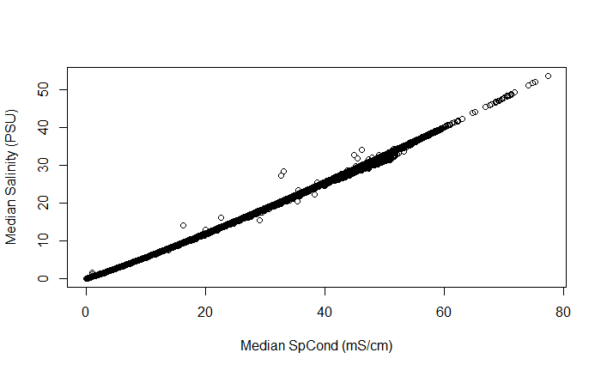

**Fig. 1.** Relationship between sonde salinity measurements and SpCond. In this dataset SpCond is dominated by salinity influence. Further, salinity PSU on the YSI EXO2 Sonde is calculated from SpCond measurements.

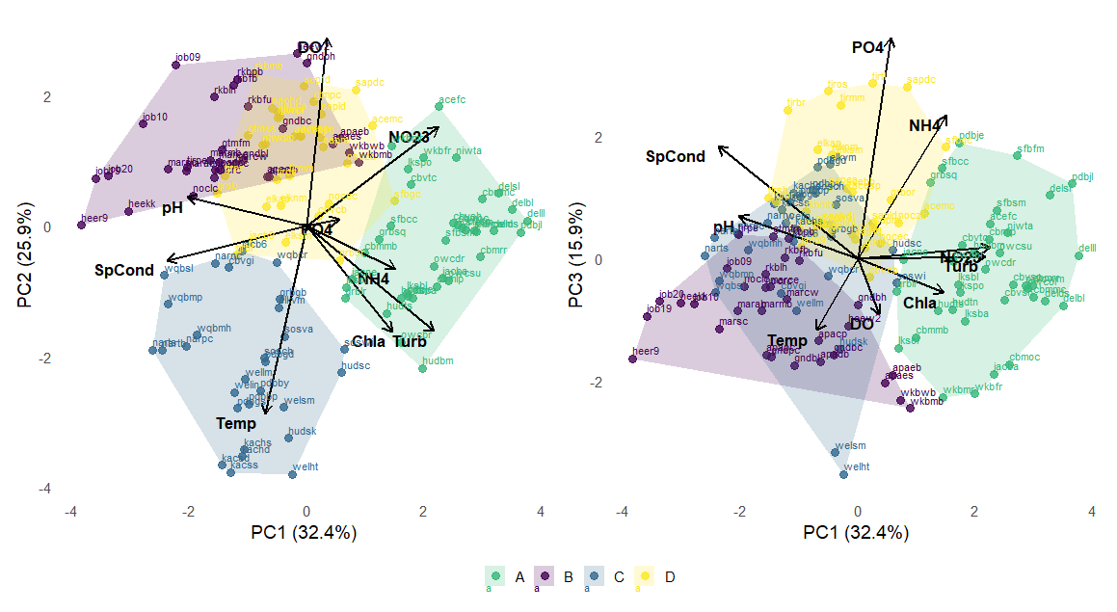

**Fig. 2.** PCA showing PC1 and PC2 (left) and PC1 and PC3). All points are annotated with station codes.

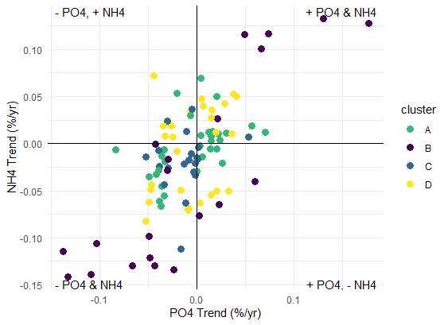

**Fig. 3.** Biplot of phosphate (PO4) and ammonium (NH4) trends colored by cluster.

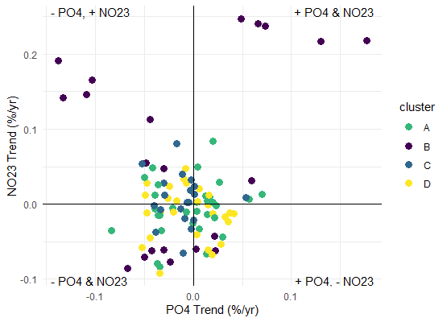

**Fig. 4.** Biplot of phosphate (PO4) and nitrite+nitrate (NO23) trends colored by cluster.

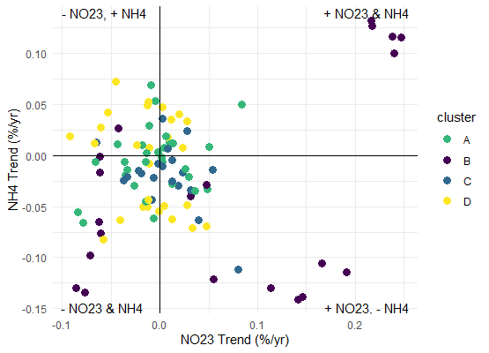

**Fig. 5.** Biplot of nitrite+nitrate (NO23) and ammonium (NH4) trends colored by cluster.

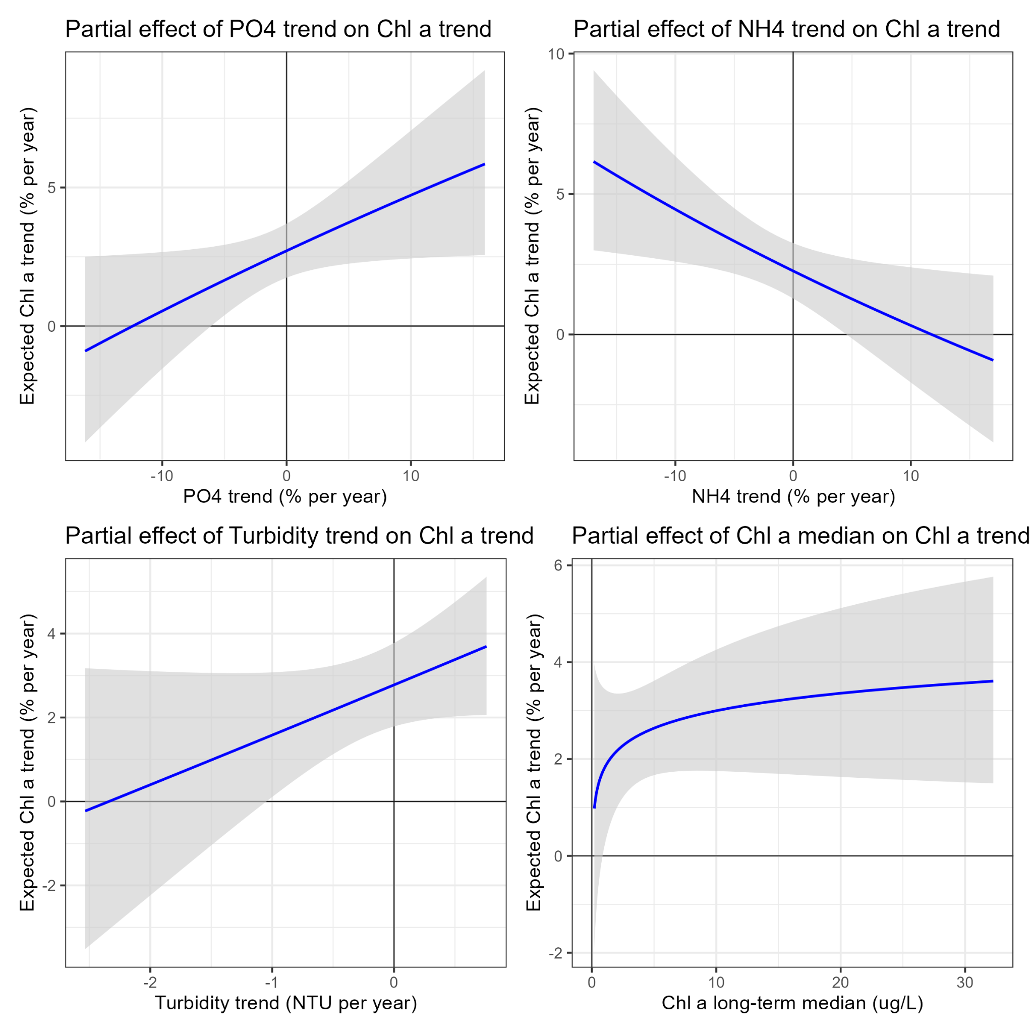

**Fig. 6.** Partial effects plots for the top four predictors in the chlorophyll-a (chl-a) trend model. Each panel shows the predictor effect when all other predictors are held constant at their average value.

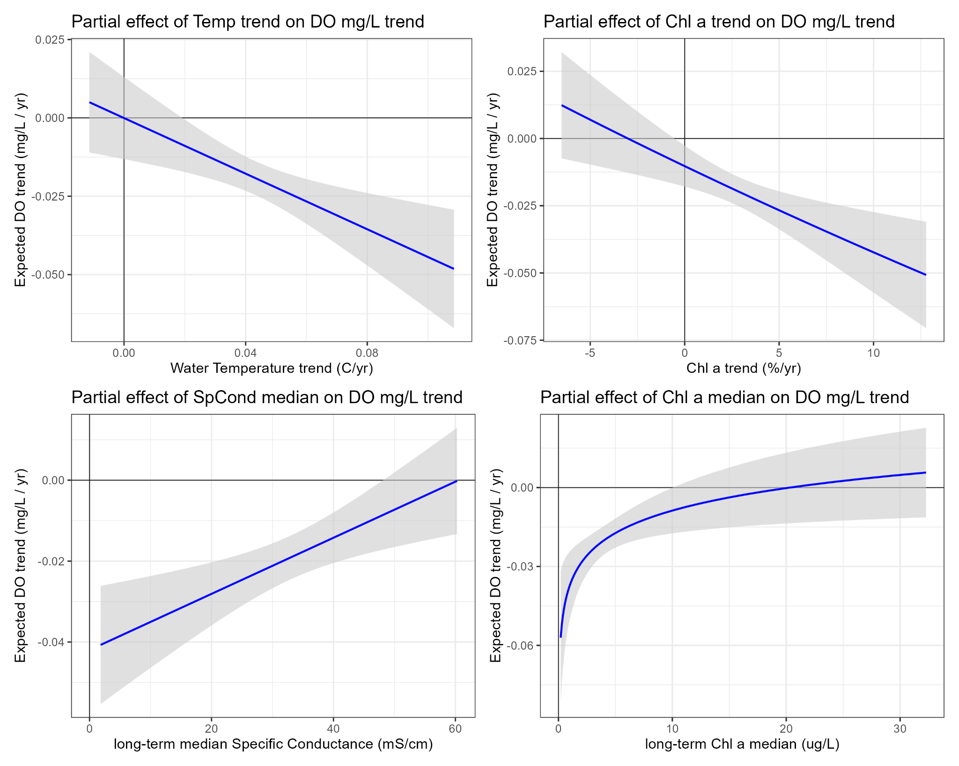

**Fig. 7.** Partial effects plots for the top four predictors in the dissolved oxygen (DO) trend model. Each panel shows the predictor effect when all other predictors are held constant at their average value.

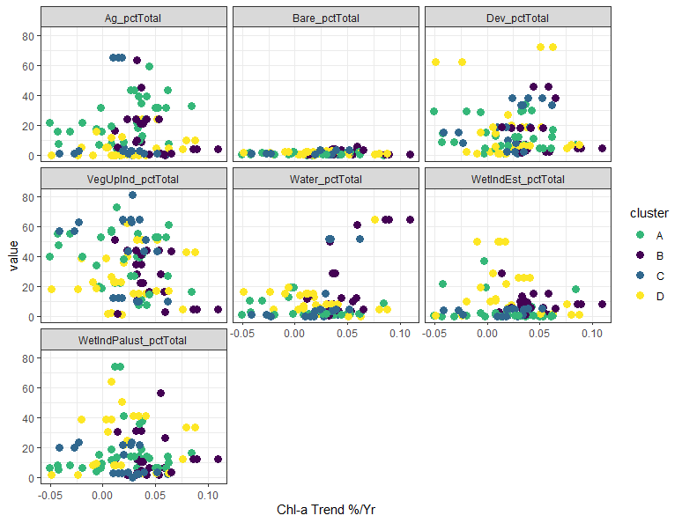

**Fig. 8.** Relationship between chlorophyll-a trend slope and percent cover for various NLCD land use/land cover (LULC) categories at the HUC 12 watershed scale.

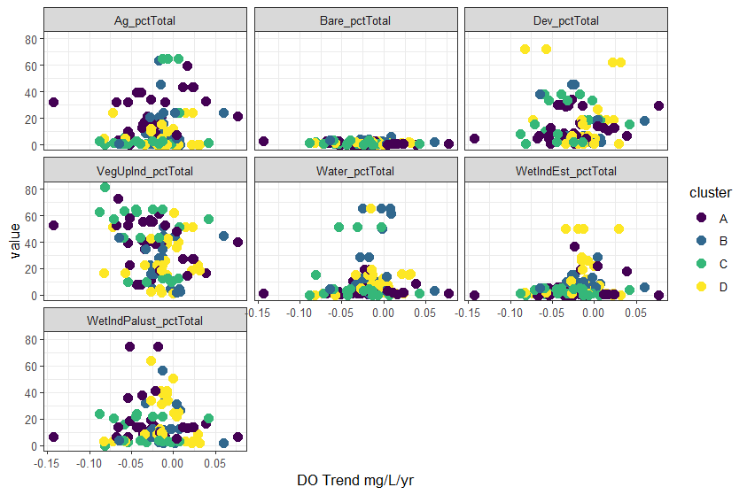

**Fig. 9.** Relationship between dissolved oxygen (DO) trend slope and percent cover for various NLCD land use/land cover (LULC) categories at the HUC 12 watershed scale..

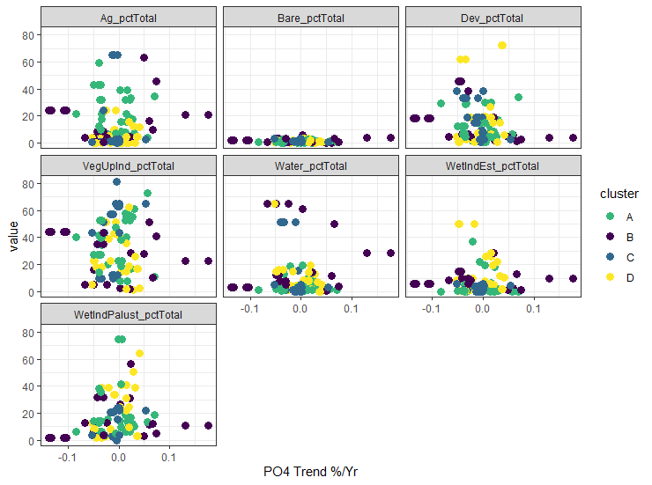

**Fig. 10.** Relationship between nutrient trend slopes and percent cover for various NLCD land use/land cover (LULC) categories at the HUC 12 watershed scale.

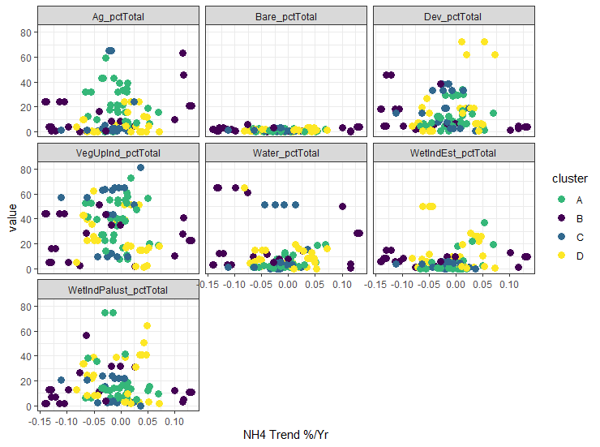

**Fig. 11.** Relationship between nutrient trend slopes and percent cover for various NLCD land use/land cover (LULC) categories at the HUC 12 watershed scale.

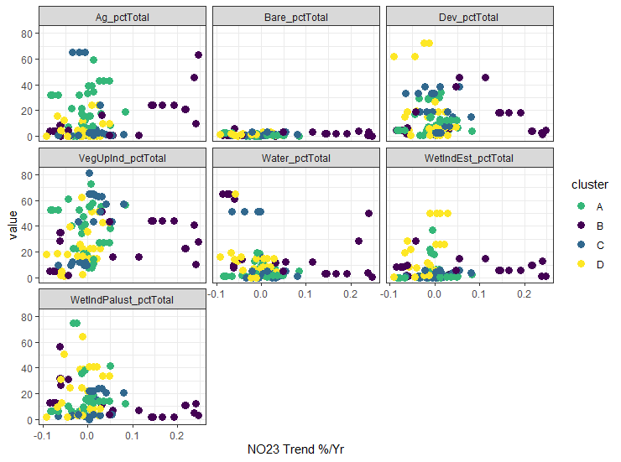

**Fig. 12.** Relationship between nutrient trend slopes and percent cover for various NLCD land use/land cover (LULC) categories at the HUC 12 watershed scale.

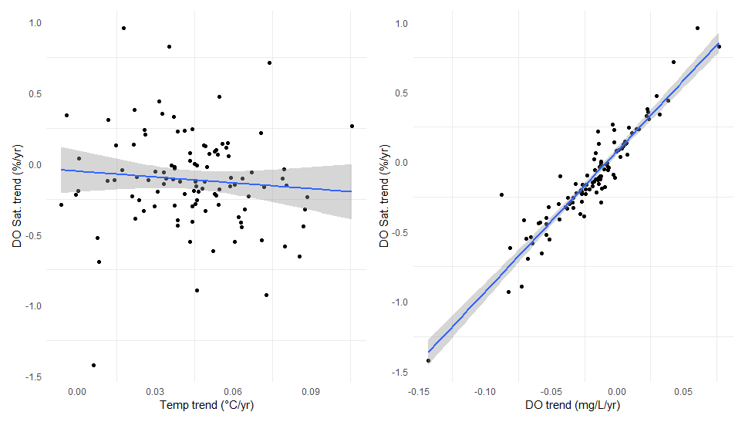

**Fig. 13.** Relationship between dissolved oxygen (DO) saturation trend and temperature trend (left) and DO concentration trend and DO saturation trend (right).

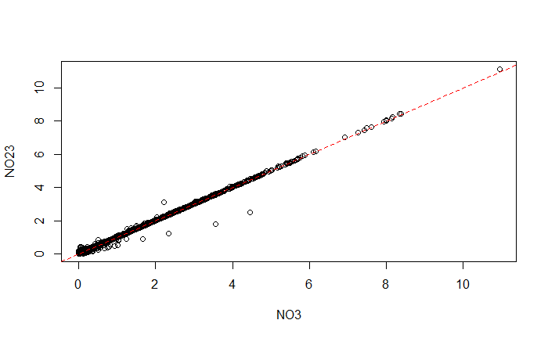

**Fig. 14.** Relationship between median nitrate (NO3) and nitrite+nitrate (NO23). The red dashed line indicates a 1:1 relationship.

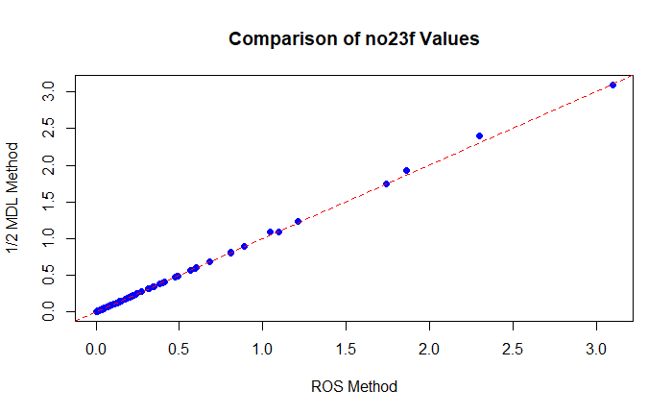

**Fig. 17.** Comparison of estimates for nitrite+nitrate (NO23) values below the method detection limit (MDL) using ½ MDL and Regression on Order Statistics (ROS) methods.

**Table 1.** Summary of monitoring stations included in the analysis, showing station metadata (name, location, and Reserve affiliation), state, geographic coordinates, and the start and end years of available water quality (wq) and nutrient (nut) monitoring data. Time series lengths (in years) are reported for both datasets

**Table 2.** PCA and cluster analysis output. Nutrient, chlorophyll-a (chl-a), and turbidity values were log transformed before PCA values were computed.

**Table 3.** Median values for all parameters.

**Table 4.**Water quality, nutrient, and chl-a slopes and associated statistics.

**Table 5.** Full chl-a trend model results for all predictors.

**Table 6.** Full dissolved oxygen (DO) trend model results for all predictors.

**Table 7.** Description of analyzed parameters used in trend modeling, including data type, parameter names (analyzed and measured), descriptions, units of measurement, data transformations applied, distribution families used in Generalized Additive Models (GAMs), and the units of reported trend slopes.